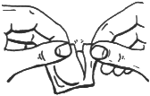
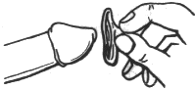
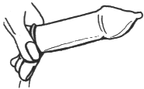
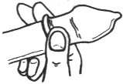

HOW TO USE A CONDOM

- Put the condom on when the penis is erect, before there is any contact between the penis and your partner’s body. Fluid from the penis during the early stages of an erection can contain sperm and organisms that can cause STIs.

- Tear along one side of the foil being sure not to rip the condom inside. Carefully remove the condom.

- Squeeze the tip of the condom between your forefinger and thumb (to avoid air trapped inside the condom, which could cause it to break) and place the condom over the erect penis. Be sure that the roll is on the outside.

- While still squeezing the tip, use your other hand to unroll the condom gently down the full length of the penis.

- Immediately after ejaculation, while the penis is still erect, withdraw the penis holding the condom firmly in place. Remove the condom only when the penis is fully withdrawn.

- Tie the used condom in a knot to prevent spillage and also to check for leaks. Throw the condom away in the trash. Do not flush condom down the toilet.
NEVER USE A CONDOM MORE THAN ONCE.

TIPS: Latex, nonoxynol-9 condoms are the most effective condom type in preventing pregnancy and STIs (the only 100% effective method is abstinence). Before using a condom always check for a valid expiration date and intact air pocket (condom should feel like a little pillow). If there is no air pocket, wrapper had leak or tear and condom is not good.

