Sobering Up
An evening of heavy drinking follows you the next day. Alcohol leaves the system at a rate of .015 percent per hour (***a little less than one standard drink per hour). Drinking coffee, taking showers and other activities have no effect on the speed with which you “sober up”.

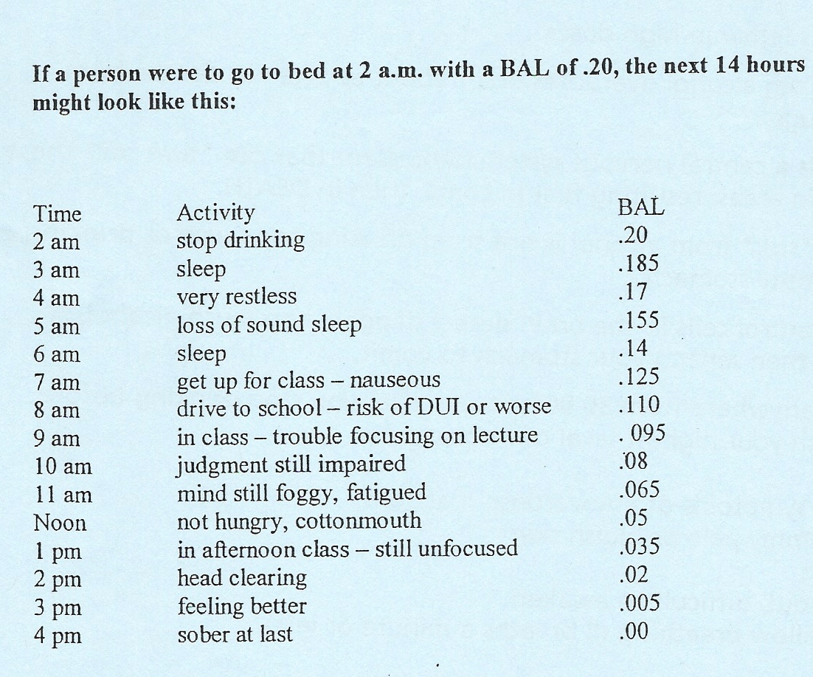

** One standard drink = one 12 oz. beer, one 5 oz. glass of wine, or one 1.5 oz. shot of hard alcohol**

For More Info Contact the Wellness Office at EXT 3413
Sponsored by the HAWEs

